1. Given the provided data, what are three conclusions that we can draw about crowdfunding campaigns?

* After comparing outcome with Average of the Successful Campaigns Vs Failed Campaigns, looks like crowdfunding campaigns data looks better in this case which is 851 VS 585.

* Though average number may be lower than most expect, but it is still plenty to get an initial initiative off the ground.
* Backers also well supported in raising the fund and achieving the targets closer what is expected.
* Though cancelled outcomes are low from the below line graph, it will be good to analyse the reasons behind, such as the goals are not realistic to achieve.

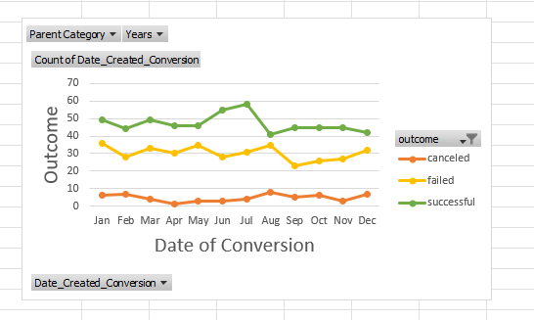

* Film, Video & Music Campaigns are more successful compared to other Campaigns which gives the clear decision making that investing money in those areas are more beneficial compared to others.

1. What are some limitations of this dataset?

* There is a risk associated with the outcome of this dataset, Failed percent chances are more, if the deadlines are not met with the goals and backers lose their confidence in the projects.
* There is no enough metrics that describe the success of each category/sub-category as a whole during the given time period. It would be helpful to have dataset that shows whether category/subcategory does well or poorly outside the relevant time periods. This might help us to determine external factors which could help in analysing the data.
* There is no enough evidence what each backer is hoping to achieve, either ambitious/expensive goals or smaller/cheap goals, so that to conclude which goal is better to achieve the immediate results with the raised crowdfunding goals.

1. What are some other possible tables and/or graphs that we could create, and what additional value would they provide?

* Additional pivot tables and graphs to show outcomes for each category along with sub-category which is most popular under it, to consider for the future other crowdfunding campaigns in this space.
* Additional metric showing the most popular categories/subcategories Vs the mot failed categories/subcategories and detailed level of data that contributes success outcomes for each category/subcategory.

This includes:

* Mean, Median, Min, Max, Variance, Standard deviation for each category/subcategory showing success/failure outcomes out of this dataset.
* Median, Max, and Min of average goals per category/subcategory,
* Goals Vs Percent funded per category/subcategory.